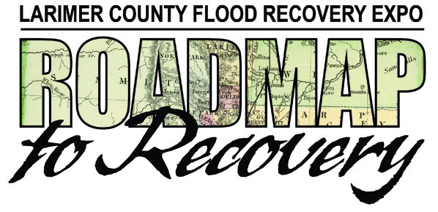

**Exhibitor Map – See Reverse Side for List of Names and Booth Numbers. If you have trouble finding a booth, please ask one of our Mountain Outreach team members in the blue shirts.**